Project Two: Summary and Reflections Report
How I Approached Testing the Three Services
When I started Project One, I did not think about testing as something separate from coding. I treated it as part of building the feature. For Contact, Task, and Appointment, I kept the requirement list open while writing tests and went line by line. If the assignment said a field must not be null, I wrote a test that passed null. If it said there was a character limit, I tested the exact limit and then went one character over.
For Contact, I tested ID rules first. It had to be unique, not null, no longer than 10 characters, and not updatable. Then I moved to first name, last name, phone, and address. On the service side, I tested adding, deleting, and updating contacts. I also tested that duplicate IDs were rejected.
For Task, I followed the same structure. I tested taskId, name, and description limits in the model test. Then in the service test, I focused only on behavior such as preventing duplicate IDs and updating fields correctly.
For Appointment, I repeated the same process but paid extra attention to the date requirement. I created a past date and verified it was rejected. That was the only feature that introduced time-based validation, so I made sure it was clearly tested.
The overall pattern was simple: read the rule, write a test for it, then try to break it.

Alignment to Software Requirements
I made sure my tests directly reflected the written requirements. I did not test random behavior. I tested exactly what the assignment stated.
For example, the Contact requirement clearly states that the ID must not be null and must be 10 characters or less. I verified that using:
That line directly enforces the “10 characters or less” rule.
After realizing I initially missed some Contact validation cases earlier in the project, I added explicit lastName tests:
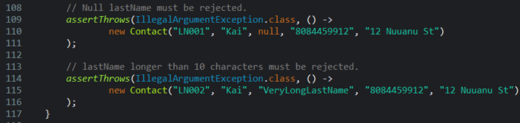
That fix made sure the lastName requirement was not assumed but actually tested.
For phone validation, I enforced the “exactly 10 digits” and “digits only” rules:
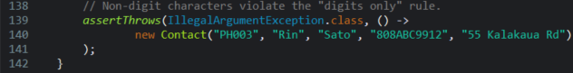

For Task validation, I confirmed taskId rules with:
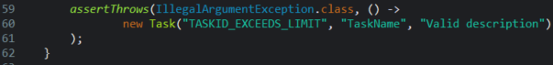
For Appointment, I verified both null and past dates:
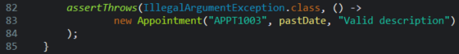
Each of these lines ties directly back to a written requirement. That is how I ensured alignment.

Writing Technically Sound Code
Technically sound code means invalid states cannot exist in the system. I enforced this by making sure all improper inputs resulted in controlled failure through IllegalArgumentException.
For example, a null phone number must be rejected:
This prevents incomplete or corrupt contact records from being created.
I also confirmed that contactId remains immutable:
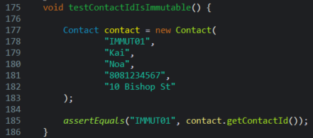
Since there is no setter for contactId and the value remains unchanged, this protects identity consistency.
For Appointment validation, rejecting past dates ensures the system cannot store logically invalid scheduling data:
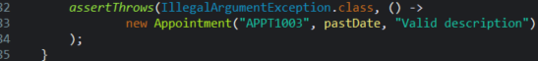
By testing these failure paths directly, I ensured the system fails safely rather than silently allowing incorrect data.

Reflection
Testing Techniques I Used
The main technique I used was unit testing with JUnit. I tested each class separately. I used assertEquals for correct values and assertThrows for invalid input. I also used boundary testing. If a field had a maximum length, I tested a value exactly at the limit and one over the limit. That ensured the boundary was actually enforced. This approach works well for backend services where strict rule enforcement matters more than user interface behavior.
Testing Techniques I Did Not Use
I did not use integration testing because the services did not connect to a database or any external systems, so there was nothing to test across multiple components. I also did not use system testing since there was no full application or user interface involved in this project. In addition, performance testing was not necessary because there were no load, speed, or timing requirements to evaluate. While those testing methods are important in larger or more complex systems, unit testing was the appropriate strategy for this project given its scope and structure.
Practical Uses and Implications
Unit testing is effective when building services that must enforce rules consistently. It helps catch issues early and keeps data valid. In larger projects, integration testing would be necessary when services communicate with databases or APIs. System testing would be required when validating complete workflows. Performance testing would matter if the system handled high traffic, this project reinforced that testing strategy depends on the system being built.
Mindset: Caution
I approached testing with the mindset that something could break. I intentionally tested null values, duplicates, and boundary limits. If duplicate IDs were not tested, the service could allow conflicting records. If past dates were not tested, appointments could be created incorrectly. Small gaps in validation can cause larger problems later, testing carefully prevents that.
Mindset: Limiting Bias
Testing your own code can create bias, It is easy to believe it works because you wrote it. After realizing I had missed some Contact validation tests early on, I became more careful. I stopped relying on memory and started verifying each requirement directly. I also used coverage reports instead of assuming I had tested enough, trying to break my own code instead of proving it worked and helped reduce bias.
Discipline and Quality
Skipping edge cases would have been faster, but it would not have met the requirements. Not testing invalid input creates technical debt and problems that slip through become harder to fix later. Going forward, I plan to always connect each requirement to a test, verify coverage meets expectations, and includes negative scenarios. Quality in backend systems depends on discipline in validation and testing. This project helped reinforce that.

